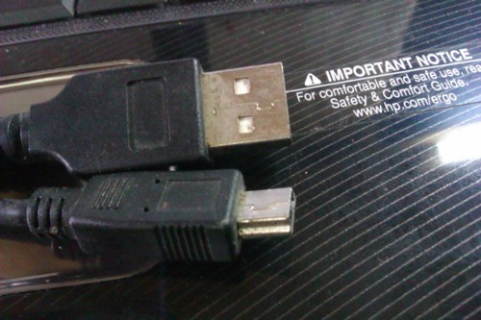

Was getting bored. Spotted a broken USB cable which I happened to get back home from Manipal. Also, unboxed my brand new multimeter. Which is quite awesome, by the way. And I do love to click pics. Hence, this infographic. :D

So, lets see what’s inside one. Using a pair of wire cutters, I broke off a piece of the broken wire, so as to remove the insulating material.

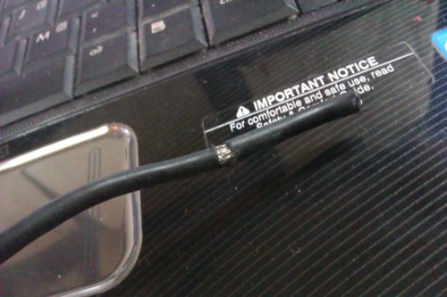

So, if you strip of that piece of insulating material, you get this:

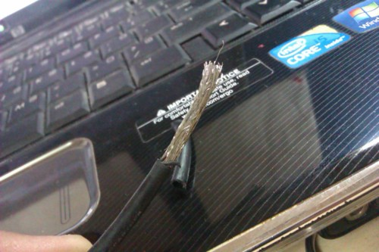

The outer strands are just a sheet to protect the insulated interiors (which are four wires, which shall be seen later). These strands do not make up a part of the transmission of signals through the cable.  
Anyways, moving the strands aside, you see this:

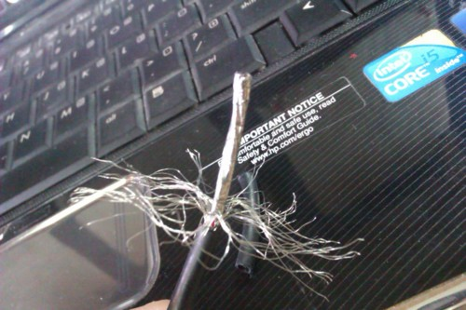

The middle part, is an insulating sheet which holds the four wires together and protects them from external charge and electronic noise. Opening up the insulating layer, we find inside four wires - Red, Black, Green and White.

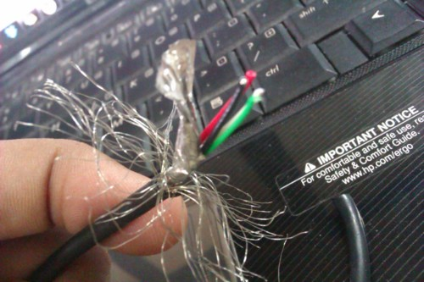

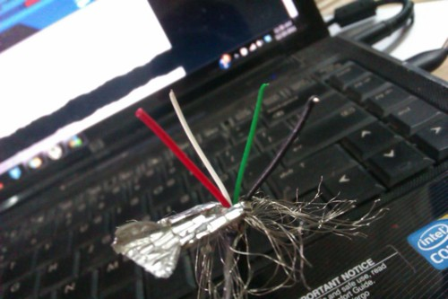

Here’s what each wire does:  
RED: Vcc  
BLACK: Gnd  
GREEN: USB data (+)  
WHITE: USB data (-)  
(Green and white are sometimes interchanged. As in, in some cables, USB data (+) is white and (-) is green)  
  
Anyways, moving on: I did not get time to mess around with the (+) and (-) data wires, but I sure tried lighting an LED with the supply wires.  
  
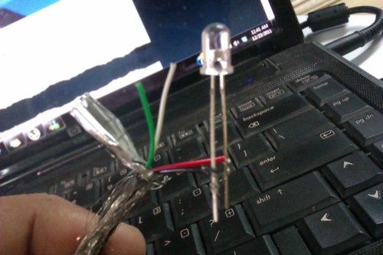  
Unfortunately, the (and my only) LED burnt. :/  
Hence, I decided to use my brand new multimeter to check the voltage:

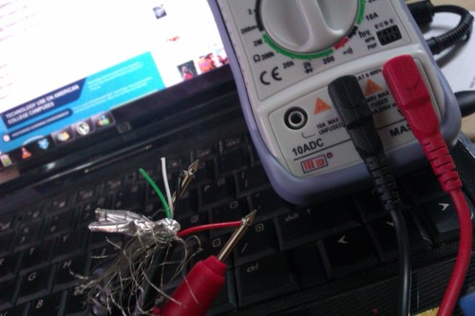

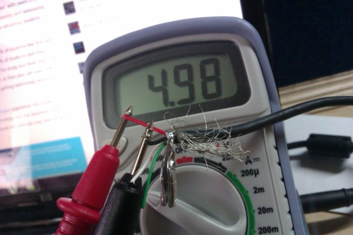

That’s pretty cool. About 5 volts. Could use this in some project if a USB cable is required. :D  
Oh, and a friend just asked me on Facebook on how I got 5 volts off just a cable. Well, if you have the same doubt, I /connected it to the USB port!/  
  
Anyways, off now. More infographics if I find any broken, not-to-be-used stuff lying around. :D  
  
Signing off…